Computer Shop System

Version 1.0

Revision History

|  |  |  |  |
| --- | --- | --- | --- |
| **Date** | **Version** | **Description** | **Author** |
| 10/12/2019 | 1.0 | details | Pham Thi Hong Trang |
|  |  |  |  |
|  |  |  |  |
|  |  |  |  |

Table of Contents

1. Use-Case Name 3

1.1 Brief Description 3

2. Flow of Events 3

2.1 Basic Flow 3

2.2 Alternative Flows 3

2.2.1 < First Alternative Flow > 3

2.2.2 < Second Alternative Flow > 3

3. Special Requirements 3

3.1 < First Special Requirement > 3

4. Preconditions 3

4.1 < Precondition One > 3

5. Postconditions 3

5.1 < Postcondition One > 3

6. Extension Points 3

6.1 <Name of Extension Point> 3

# Delete Customer Feedback

## Brief Description

This use case defines steps to delete an unsuitable feedback which is an impolite feedback effecting directly to computer shop.

# Flow of Events

## Basic Flow

This function belongs to admin. First, they click in manage customer feedback. If the feedback list has some impolite feedbacks, admin will click in deleting by X button. The system will delete this feedback in the database and update it in manage customer feedback

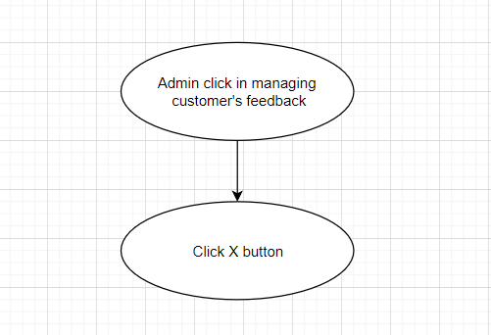

**Basic flow of deleting a feedback**

.

# Special Requirements

Admin should only delete impolite feedbacks.

# Preconditions

Admin already log in the computer shop.

# Post conditions

No post conditions.

# Extension Points

No extension points.